Time Efficient Wireless Technology Based  
Biometric Attendance System

Summary:

This project presents a cost-effective wireless biometric attendance system having the fastest data transfer rate. It ismore user friendly than the previous versions of any attendancesystem. The main focus is to develop an automated fingerprintbased attendance system and also an information service systemfor an academic domain by using biometric technology inaddition to the programmable logic circuit (Arduino) and web-based application. The system also includes Bluetooth technologyfor smooth operation and low costing. The capability to operateat both AC (Alternating Current) and DC (Direct Current) powersources makes this system more attractive and efficient.

**Apparatus:**

HC-05, FPM 10A, Arduino Uno, TTL, Power supply, Cooler fan, Lipo battery, Bug converter, Relay, Charger battery, Casing, Cod.

**Overview of the Proposed System:**

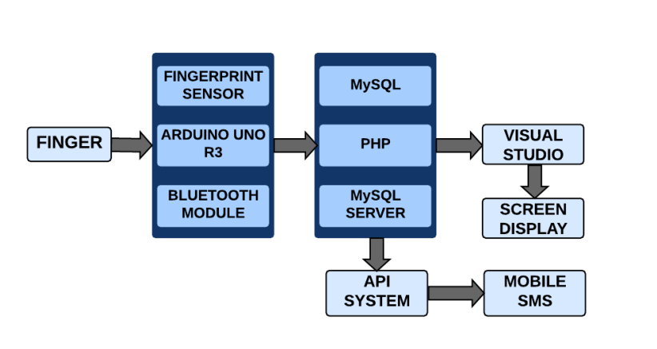

Fig. 1. Block diagram of the proposed system architecture.

The block diagram of the proposed system architecture is given in Fig. 1. This shows the simple block diagram of the whole proposed system. The arrow indicates the step by the step data flow.

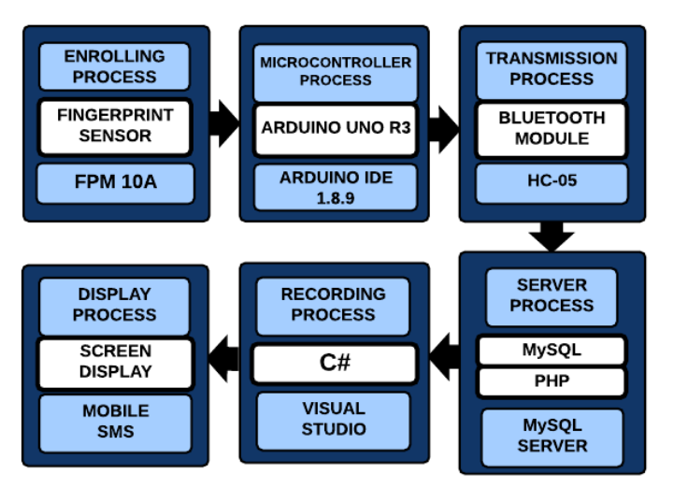

Fig. 2. Procedural steps of the proposed system architecture.

The procedural steps of the proposed system architecture are shown in Fig. 2.

The first thing in the hardware unit is the enrolling process which describes the enrolling technique of each student's fingerprint identification (ID). The fingerprint module contains digital signal processing (DSP) chip inside it that identifies fingerprints using SmakFinger3.0 Algorithm. Then the microcontroller unit containing Arduino Uno acts as the processor for the whole system. Bluetooth module involves in transmission unit for wireless data communication.

In the software unit, there is a server process that stores each student’s additional information. It uses a MySQL server for storage management. In the recording portion, the matched fingerprint data is sent to the database, which can be accessed anytime. The final work is to display the attendant student’s information and send notifications via mobile message to each student’s corresponding concerned people.

**Hardware Design Considerations**

The proposed system is made up of many components. Every component has its functions. The Arduino Uno is used as the central processing unit in this system. The proposed method consists of a fingerprint sensor (FPM10A), two HC-05 Bluetooth modules, a PL2303 USB to Serial (TTL) module, a dc-dc buck converter, a rechargeable lipo battery, and the power supply. A cooling fan is also used for the cooling purpose of the whole circuitry. The hardware setup shows how all types of equipment are connected.

1. **Arduino Uno**

The Arduino Uno is a microcontroller board based on the ATmega328. It has 14 digital input/output pins (of which six are used as PWM outputs), six analog inputs, a 16 MHz ceramic resonator, a USB connection, a power jack, an ICSP header, and a reset button. Its operating voltage is 5V, but its input voltage has a limit of 6 to 20V with DC Current per I/O Pin of 40mA.

1. **FPM10A Optical Fingerprint Reader Sensor**

This sensor works on a 3.6 to 6V voltage supply and less than 120mA current supply. Four pins of this sensor are connected to the Arduino for interfacing. VCC, TX, RX, and GND are connected respectively with Arduino’s 5V, RX, TX, and GND. Installing the Adafruit Fingerprint Sensor library, this sensor module enrolls new fingerprints. Placing a finger, it finds a match with a specific ID.

1. **HC-05 Bluetooth Module**

The HC-05 is a Bluetooth-to-serial converter that connects microcontrollers to other devices and allows them to communicate wirelessly. Four pins RX, TX, GND, and VCC of this module are connected respectively with Arduino’s TX, RX, GND, and 3.3V.

1. **PL2303 USB to Serial (TTL) module**

It’s a small USB to TTL serial tool, using the PL2303 chip. It used to connect some serial devices to a PC via USB port. Four pins RX, TX, GND, and 5V of this module connected with the TX, RX, GND, and VCC of the HC-05 Bluetooth module.

1. **DC-DC Buck Converter**

DC-DC Buck Converter is a step-down(buck) power module with a high precision potentiometer, capable of driving a load up to 3A with high efficiency, which can work with Arduino UNO, other mainboards, and basic modules. These devices are accessible in fixed output voltages of 3.3 V, 5 V, and 12 V, and an adjustable output variant.

1. **Rechargeable Li-Po Battery**

We have used a 9V Li-Po battery, but the input voltage can not be more than 5V. That is why the dc-dc buck converter is used to reduce the input voltage from 9 to 5V. It has DC voltage coming in and DC voltage going out. The output voltage can be varied as we need.

The complete hardware setup of the proposed system connecting all the components where the front view, and the inside view respectively, shown in Fig. 3(a), and in Fig. 3(b).

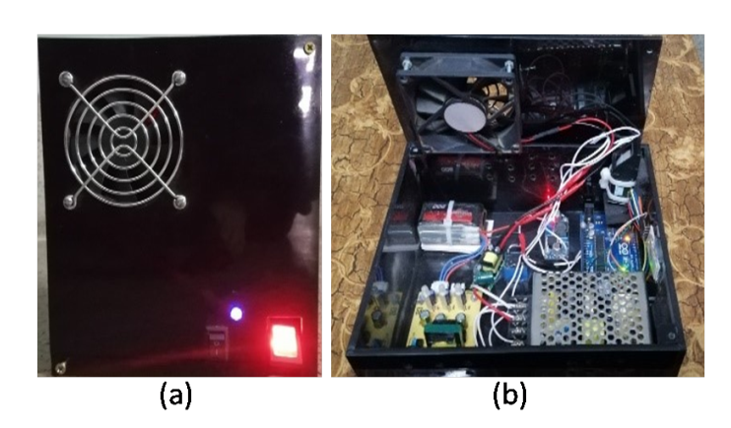

Fig. 3. (a) Front view, and (b) Inside view of the proposed system.

**Software Design Considerations**

In the software development section, two languages are used. A Visual Basic programming language used for making an .exe application file. The .exe application file contains a serial port, a box showing the last ID, a timer, a connect/disconnect button, and an exit button. While taking data from the modules, the connect button should be on. Otherwise, the data will not store on the specified database. Another language is Visual C, which is used to complete the web configuration. The VB-IDE supports rapid application development to develop graphical user interfaces (GUI) for connecting them to handler functions. With the formed database, it can quickly check because a view option is made from where a teacher can easily access a student’s daily attendance. The student can also have access to the student login option where an API is used for transferring a message to the concerned people like Department Head or parents. The database stores the enrolled value only. The fingerprints which are not enrolled before would not be stored in the database if the fingerprint was pressed while taking attendance. The Bluetooth module passes the data to another Bluetooth module, which is connected with the USB to Serial (TTL) module. With the help of this module, the data goes through the database. But it needs a secure internet connection to collect the data and sending the messages to the corresponding numbers. The API system works with an internet connection. It requires an amount of balance in the API system to send the messages. Otherwise, the messaging system will not work, and the concerned people will not be able to get the proper reports.

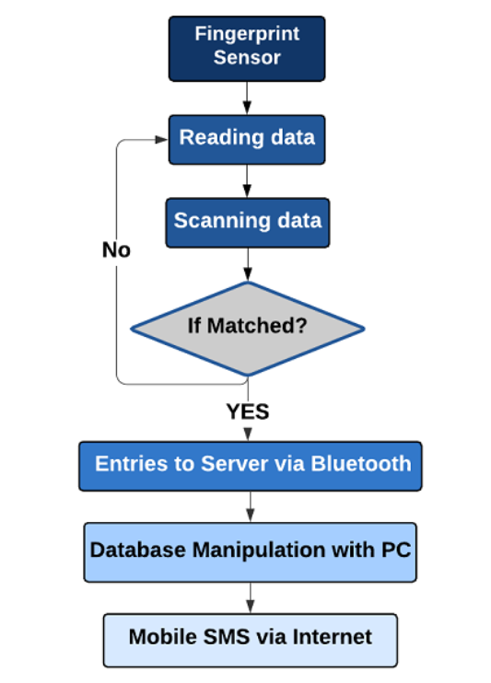

Fig. 4. Overall working flowchart of the proposed system.

Fig. 4 represents the working procedure of the developed system through a flowchart.